2APHY Motion and Force: Assignment One DUE Thursday 12th March.

Name: _______________________________________________ (40 marks total)
Note:
- All answers to be in S.I. units of metres, seconds and metres per second unless stated.
- All working must be shown for full marks.
- All problems assume no air resistance.

- Little Johnny is riding around the park on a circular path. The path has a radius of 8.00 m and it takes Johnny 40.0 s to complete the circle. At what speed was Johnny riding his tricycle? (3 marks)

- Draw a displacement/time graph of the following situation. Leave the time in minutes.

Fern (my ginger cat) is out hunting for mice in the bush. She travels north for 90.0 m in 8.00 minutes, stops for 4.00 minutes to look around. She then travels 70.0 m south in 6.00 minutes and stops for 4.00 minutes while she looks around. She then hears me calling her so she runs 1.20 x 10² m north at an average velocity of 2.00 ms⁻¹ where she knows her dinner is waiting for her. (Note: Space has been left below the graph of any working you require.) (4 marks)

This space has been left for any working you require.

- 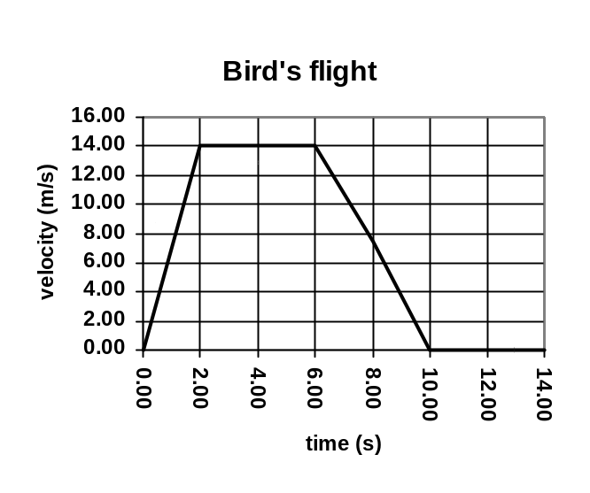Look at the graph which shows the journey of a bird taken every two seconds from when it took off from the ground. Calculate the total displacement of the bird using only the graph. (3 marks)

- A cheetah on the hunt is travelling at 54.0 kmh⁻¹ when she selects her prey. She accelerates at a rate of 2.00 ms⁻² for 2.50 s to catch her prey. At that point, what was the cheetah’s final velocity in kilometres per hour? Don’t forget, you must convert to ms⁻¹ for calculating final velocity before converting back to kmh⁻¹. (3 marks)

- Jake is out walking his dog. Firstly he walks 2.40 km west (to point A) then 3.20 km south (to point B). At this point he decides to heads for home by the shortest route. Determine his displacement in metres from home to point B. Include a labelled vector diagram with your answer. (3 marks)

- Victoria sees a traffic light turn orange when she is 45.0 m from it. She has a reaction time of 1.20 s and she is travelling at 61.2 kmh⁻¹. Calculate her acceleration so as to stop at the traffic light?
(3 marks)

- Melissa is very angry. She just found out that her boyfriend is two-timing her. She goes to the bridge overlooking Collie River where he first asked her to go steady and, taking off the friendship ring he gave her, throws it into the water below with an initial velocity of 4.60 ms⁻¹. If the ring takes 0.800 s to hit the water, calculate:
- how far the ring was above the water? (2 marks)

- the ring’s velocity when it hits the water? (2 marks)

- A helicopter is ascending (rising) at a constant velocity of 4.50 ms¹ when a small package accidentally falls out of the helicopter when it is 350.0 m above the ground. If the package falls to the ground,
- how long before the package hits the ground from the moment it left the helicopter? (3 marks)

- what will be its velocity when it hits the ground? (Note: for this question only, you must NOT use value of time calculate in part (a), use original data in question.) (3 marks)

- Mandy is a mouse, with a maximum acceleration of 0.250 ms⁻². Cliff is a cat who can accelerate at 0.400 ms⁻² when chasing a mouse. One day, Cliff and Mandy saw one another at the same moment. Mandy immediately took off towards a hole in the wall, 2.50 m away. While Mandy accelerated, Cliff took 1.00 seconds to start running. He then accelerated directly toward the hole in the wall, 3.60 m away.

  - From the moment he took off, how long did Cliff take to run the 3.60 m to the wall? (2 marks)

  - How long did Mandy have to get away? (2 marks)

  - How far could Mandy travel in this time? (2 marks)

  - Could Mandy reach the hole in the wall before Cliff arrived? Explain. (2 marks)
________________________________________________________________________________________________________________________________________________________________________________________________________________________________________________________________________________________________________________________________________________________________________________________________________________________________________________________________________________________________________________________________________________________________________________
- Sammy the seal is walking along the beach at 1.55 ms⁻¹ East when he sees another male moving in on his females so he accelerates to 3.20 ms⁻¹ East. Calculate Sammy’s change in velocity. You must include a diagram and direction in your answer for full marks. (3 marks)

